Brand | Hybrid  Trait | Number of Rows | Row Length | Net Weight | Harvest Moisture | Test Weight | Yield Per Acre
Nortec 17XTZ27 Ex | RR2Y Xtend | 12 | 497 | 1465 | 14.7 | 55.6 | 69.9
Nortec 4266 | RR2Y | 12 | 497 | 1485 | 13.7 | 56.7 | 71.7
Nortec 17XTZ26 Ex | RR2Y Xtend | 12 | 497 | 1395 | 14.3 | 55.2 | 66.9
Nortec 4242 | RR2Y | 12 | 497 | 1360 | 14.3 | 55.5 | 65.2
Nortec 17XTZ24 Ex | RR2Y Xtend | 12 | 497 | 1310 | 12.9 | 56.4 | 63.9
Nortec 4222 | RR2Y | 12 | 497 | 1185 | 14.7 | 54.7 | 56.6
Nortec 17XTZ23 Ex | RR2Y Xtend | 12 | 497 | 1095 | 13.4 | 56.8 | 53.1
Nortec 4218 | RR2Y | 12 | 497 | 1240 | 14.5 | 55.3 | 59.5
Nortec 17XTZ22 Ex | RR2Y Xtend | 12 | 497 | 1170 | 13.5 | 56.1 | 56.6
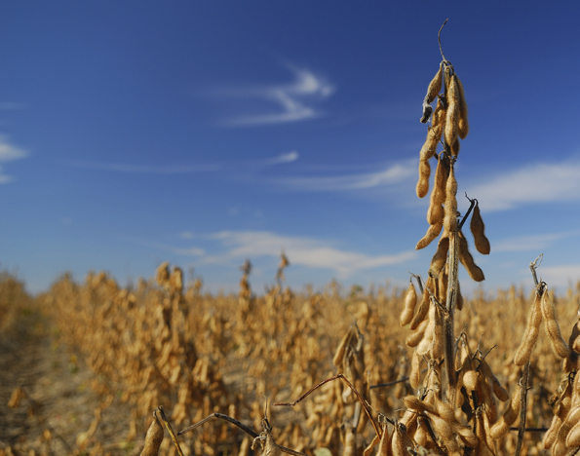 | Nortec Seeds  J&M Farms, Geddes, SD  Planting Rate: 150,000 Row Width: 30”  Date Plant: 5-05-17 Date Harv: 10-15-17  Previous Crop: Corn Min. Till: No

